Improved Hamiltonian Adaptive Control of Spacecraft

Tim Sands
663 Nautilus Ct #104
Fort Walton Beach, FL 32548
850-882-2170 timothy.sands@eglin.af.mil
Jae Jun Kim
Mail Code: MAE/Ja
Naval Postgraduate School
Monterey, CA, 93943 USA
831-656-2716
jki12@nps.navy.mil

Brij N. Agrawal
Mail Code: MAE/Ag
Naval Postgraduate School
Monterey, CA, 93943 USA
831-656-3338
agrawal@nps.edu

Abstract—Spacecraft control is complicated by on-orbit inertia uncertainties. Considerable initial, on-orbit check-out time is required for identification of accurate system models enabling fine pointing. Smart, plug-n-play control algorithms should formulate smart control signals regardless of inertia. Adaptive control techniques provide such promise. Spacecraft control has been proposed to be adapted in the inertial frame based on estimated inertia to minimize tracking error. Due to unwieldy computations, later researchers suggested adapting the control in the body frame. This paper derives this later suggested approach using the recommended 9-parameter regression model for 3-axis spacecraft rotational maneuvers. Additionally, a new 6-parameter regression model is shown to be equivalent. Further, a new 3-parameter regression model is demonstrated to yield similar performance. Finally, a new improved, simplified adaptive feedforward technique is shown to provide superior performance. Following promising simulations, experimental verification is performed on a free-floating three-axis spacecraft simulator actuated by non-redundant, single-gimbaled control moment gyroscopes.

table of contents
1. introduction…............................................................. 1
2. adaptive feedforward development………….... 2
3. regression modeling…….......................................... 4
4. 6-parameter regression............................................. 4
5. 3-parameter regression............................................. 4
6. simulations................................................................... 5
7. experimental verification....................................... 9
8. conclusions................................................................... 10
references........................................................................ 10
biography.......................................................................... 10

1. introduction
Adaptive control techniques often adapt control commands based upon errors tracking trajectories and/or estimation errors. Direct adaptive control techniques typically directly adapt the control signal without translation of estimated parameters. Indirect adaptive control techniques indirectly adapt the control signal by translating the estimates of unknown system parameters to formulate a control signal. The adaptation rule is derived using a proof that demonstrates the elimination of tracking errors (the true objective) and demonstrates stability, which is complicated by the nonlinear closed loop system. Two fields of application of adaptive control are robotic manipulators and spacecraft maneuvers utilizing either direct or indirect adaptive approaches [1], [2], [3].

While some adaptive techniques concentrate on adaptation of the feedback control, others have been suggested to modify a feedforward control command. Anderson evaluated the filtered-x LMS algorithm with FIR estimation for adapting the feedforward command signals [4]. Simpler adaption rules have been used for adaptation of the feedforward signal in the inertial reference frame [5], [6], [7]. While the adaption is simpler in general form, the resulting regression model used in the control signal requires several pages to express for three-dimensional spacecraft rotational maneuvers. Other references also utilizing the inertial frame [6], [8] have been extended to include attitude control system power tracking in the control signal [8], but still suffer from the algorithmic complexity that accompanies the inertial frame. The measured regression matrix is required in the control calculation, so this approach is computationally inappropriate for spacecraft rotational maneuvers. Subsequently, Slotine’s 9-parameter estimation general approach [6] was suggested for implementation in the body reference frame by Fossen [9]. The method was derived for slip translation of the space shuttle, but neither simulated nor experimentally verified. Nonetheless, this method appears promising for practical implementation for three-dimensional spacecraft rotational maneuvers. This paper derives the Slotine-Fossen approach for 3-dimensional spacecraft rotational maneuvers. An alternative approach utilizing non-adaptive feedback, while retaining adaptive feedforward is demonstrated to increase performance. Estimation requirements are reduced with a new six-parameter regression model and also a new three-parameter regression model. After simulations provide promise, experiments verify the effectiveness of the suggested approaches.

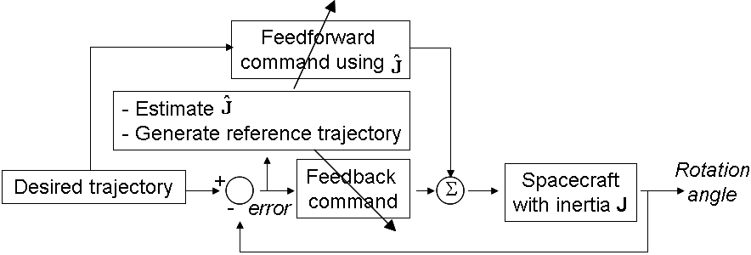
τ
Fig 1 Slotine/Fossen Adaptive control relationships

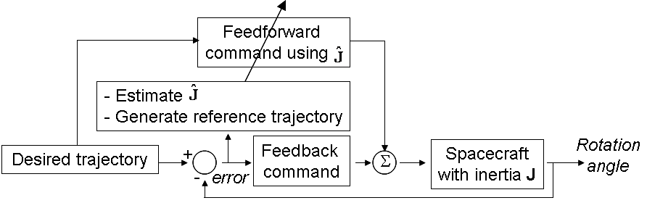
τ
Fig 2 Proposed Adaptive control relationships

The suggested algorithms may be plugged in place of any attitude control algorithm based on state feedback (angular position and velocity) to achieve the demonstrated performance increase. Since spacecraft already use angular position and velocity measurements in typical control methods (including proportional-derivative, PD control); implementation is quite easy. Input the feedforward and PD-feedback controllers with a reference trajectory and adapt the feedforward signal using a simple adaption rule that is proven to be stable and eliminate tracking errors.

2. adaptive feedforward development
After defining requisite quantities, Lyapunov stability analysis yields a stable and convergence adaptive feedforward control design with PD feedback control. First define the ideal feedforward control, u_{ff} from the dynamics. If the dynamics were exactly known, they would determine the feedforward control that would accomplish a desired maneuver 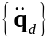in body coordinates with no error. For inertia matrix [J], Coriolis matrix [C], and applied external torque τ, the equations of motion are:

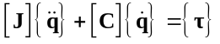 (1)
for J =J^{T}>0, =0, C=skew symmetric

Define:
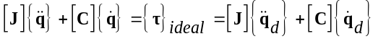
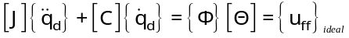 (2)

Define the tracking errors using tilda ( ~ ): 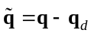

Thus 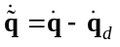and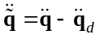 (3)

Allowing definition of the reference trajectory for λ>0

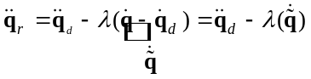 (4)
and 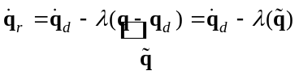 (5)
Define a combined measure of tracking error (error tracking the reference trajectory):

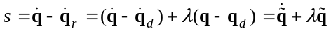 (6)

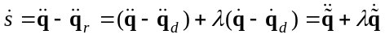 (7)

From our earlier regression definition (equation (2)) of the feedforward control, define:

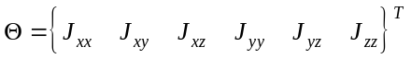 (8)
where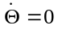for time-invariant inertia,

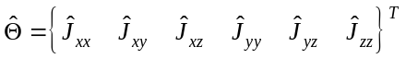 (9)

Thus, the estimated dynamics may be defined using a similar regression similar in form to the actual dynamics:

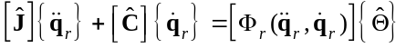 (10)

Define the estimation error as the difference between estimated and actual inertia:

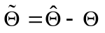 (11)

Consider the candidate Lyapunov function where K_{p} and K_{d} are proportional and derivative control gains respectively:

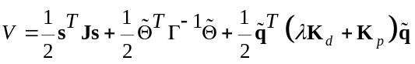 (12)

Differentiating:

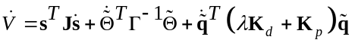 (13)

Substitute for , distribute [J], substitute for 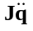and add & subtract 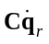grouping 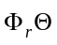. Then reverse distribute [C] and substitute 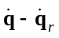for s. Use skew symmetry to reduce:

(14)

Note Fig 2 and let torque (15)

Group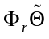and equate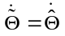:

(16)

Using the combined measure of tracking error define

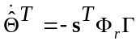 Γ>0 (17)

Cancel and substitute for 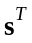 then distribute 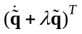twice. Group terms then reverse distribute to 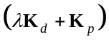canceling terms.

(18)

For negative semi-definite Lyapunov function derivative, Barbalat’s lemma says: if the differential function V(t) has a finite limit as t→∞ (bounded) and is such that 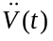exists and is bounded, then 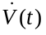→0 as t→∞. V(t) is lower bounded and is negative semi-definite, so if is uniformly continuous in time, then →0 as t→∞. To confirm uniform continuity, differentiate: and 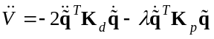. Since 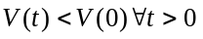, 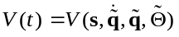 is bounded, thus 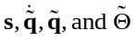are all bounded. Since and are bounded, and 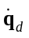& 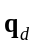are bounded inputs, and are bounded, thus, 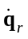is bounded. Also, since 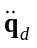is a bounded input, 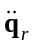 is bounded. Additionally, since 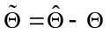is bounded, and is a bounded, real world system (no such system of infinite inertia), is bounded, thus 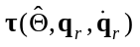is bounded. Recalling the Newton-Euler relation (equation ((1)) and our defined torque (noting we have just demonstrated and are bounded), must be bounded.

(19)

Since is bounded, is uniformly continuous. By Barbalat’s lemma: 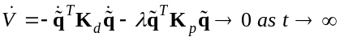.

3. regression modeling
Feedforward control utilizes Newton-Euler equations of rotational motion to derive a control command that would be perfect in a perfect world. Typically feedback control accounts for non-perfections (e.g. modeling errors, noise, etc.). The equations of motion may be written as a regression model to facilitate easy expression as matrix equations.

For specific body coordinates 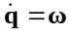, the dynamics may be written as a regression model in terms of the reference trajectory as done in Slotine/Fossen for slip translation of the Space Shuttle. The result for 3D rotational spacecraft maneuvers is

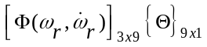=
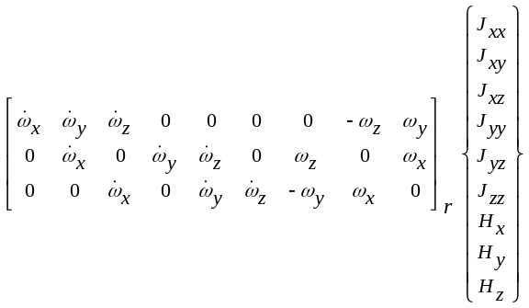

The dynamics establish the feedforward command when the inertia is known and correct. Accordingly, utilize the estimated dynamics for formulate the adapted feedforward command based on estimated inertia and the reference trajectory.

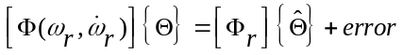 (20)

Additionally, feedback control is added utilizing the reference trajectory in PD control architecture. Slotine/Fossen utilizes the reference trajectory for feedback resulting in the following:

Notice this definition of feedback control defines the reference trajectory gain λ= K_{p} /K_{d}. Thus choice of K_{p} and K_{d} constrains/defines the reference trajectory (in the feedforward also).

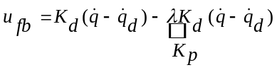 (21)

Similar to the example in [], adaptive feedforward techniques in this study are compared by fixing feedback gains: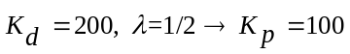. Each approach compared will have identical adaptive feedback controls. It is proposed here to maintain PD feedback control based on the desired trajectory rather than the reference:

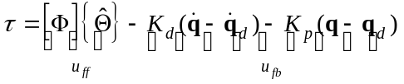 (22)

4. 6-parameter regression
Recalling {H}=[J]{ω}, substitution into the 9-parameter Slotine/Fossen regression model allows reformulation into the following equivalent 6-parameter regression model resulting in considerable simplification.

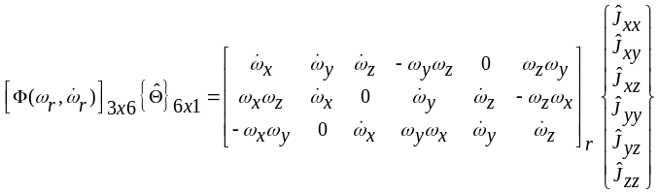

Utilizing reference feedback, this reduced form is equivalent to Slotine/Fossen’s 9-parameter estimation version and is referred to as Derived6 to denote the heritage from Slotine/Fossen, yet still indicate the alteration to a reduced form. The first proposed adaptive technique (Proposed6) utilizes this regression model (using estimates) and implements λ=1/2 fixed by feedback (thus typical PD feedback of desired trajectory) with a more aggressive reference feedforward λ_{ff}=1.

5. 3-

parameter regression
Typical assumptions for simplified spacecraft dynamics modeling include neglecting inertia cross-products. The result is the following regression model.

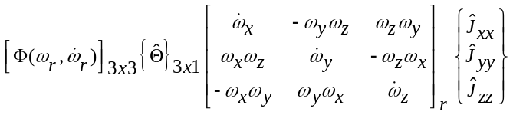

The second proposed adaptive technique (Proposed3) utilizes this regression model (replacing inertia with estimates), and implements λ=1/2 fixed by feedback (thus typical PD feedback of desired trajectory) with a more aggressive reference feedforward λ_{ff}=1.

6. simulations
In this section, a nominal target acquisitions and tracking maneuver is performed with various control techniques to compare performance. The maneuver consists of a steady yaw (earth-tracking maneuver) and sinusoidal pitch (target evasion) with equations given below . Older estimated values of the experimental testbed’s inertia (prior to installation of the optical payload) are used to design the feedforward torque command. Since the actual new inertia is unknown, the Fig 3 assumed-actual inertia components were assumed to design the classical “perfect” feedforward control for comparison. Simulated spacecraft inertia [J]_{actual_simulated} was increased 10% arbitrarily from what was assumed in the design of the feedforward control [J]_{feedforward}.

Simulations reveal considerable performance increase using Slotine/Fossen’s adaptive control. A reduced-form 6-parameter adaptive control scheme proves to perform identically well. Furthermore, eliminating reference trajectory feedback replacing it with simple PD feedback allows more aggressive adapted feedforward improving performance slightly-more. Selection of feedforward reference trajectory gain λ_{ff} establishes the limits of performance increase. Higher λ result in better performance. Note that assuming a diagonal inertia matrix (using the 3-parameter adaptive control) is superior to classical feedforward plus PD feedback control, but does not perform as well as the higher computational adaptive controls for this assumed spacecraft with non-negligible inertia off-diagonal terms.

Regardless, the simulations exhibit sufficient performance increase to attempt experimental validation on a noisy real-world, free-floating spacecraft simulator.

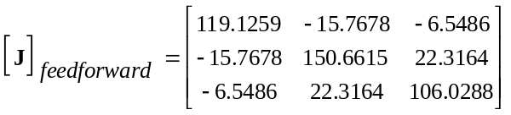
Fig 3 Spacecraft inertia assumed for comparison in simulations

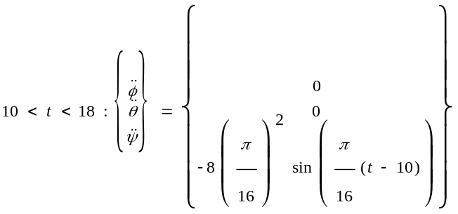
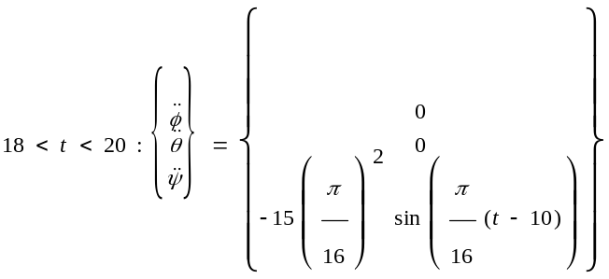
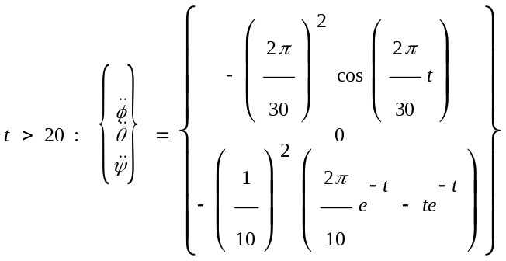
Fig 4 Commanded target acquisitions (10<t<20) and tracking trajectory (t>20) for evaluation in simulations and experimental verification.

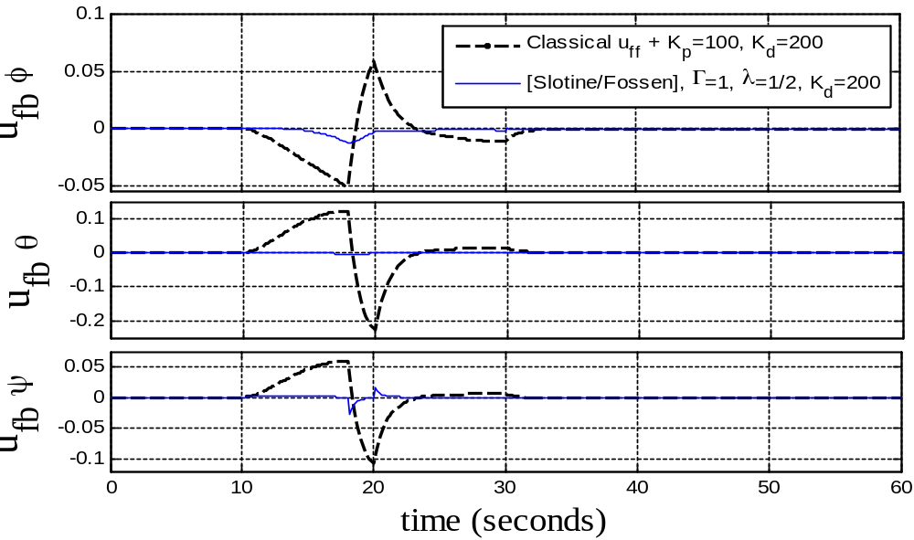
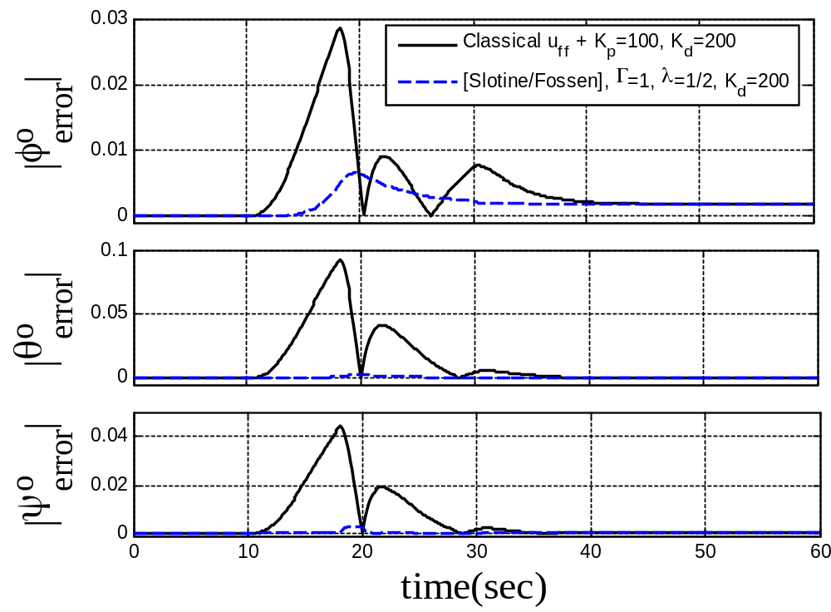
Fig 5. FEEDBACK CONTROLS: Classical feedforward + PD feedback Versus Slotine/Fossen adaptive control

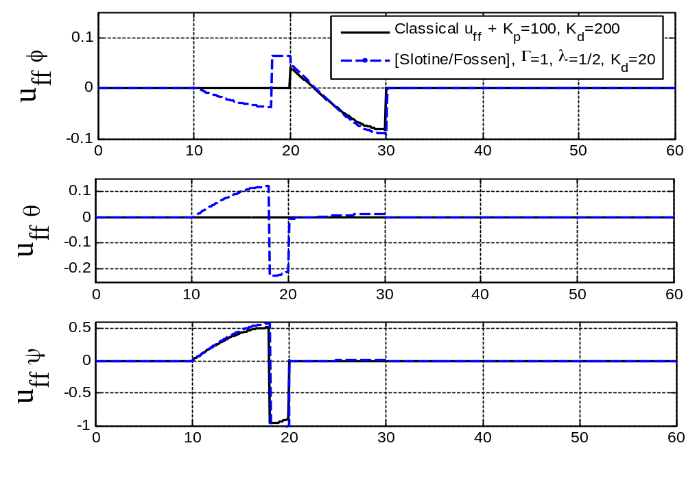
Fig 6 FEEDFORWARD CONTROLS: Classical feedforward + PD feedback Versus Slotine/Fossen adaptive control

Fig 7 TRACKING ERRORS: Classical feedforward + PD feedback Versus Slotine/Fossen adaptive control

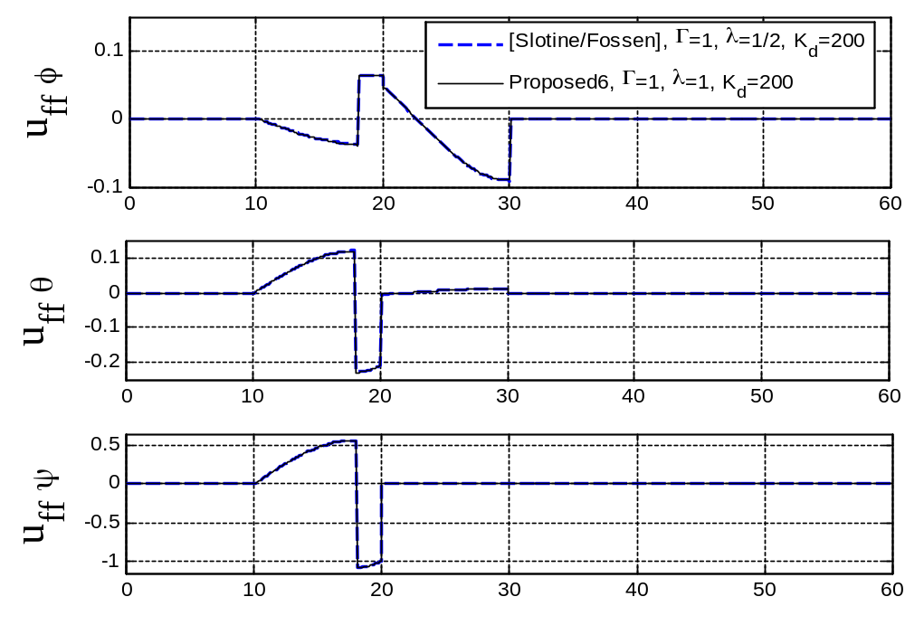
Fig 8 FEEDFORWARD CONTROLS: Slotine/Fossen Vs. Proposed6 adaptive feedforward (only) with PD feedback control

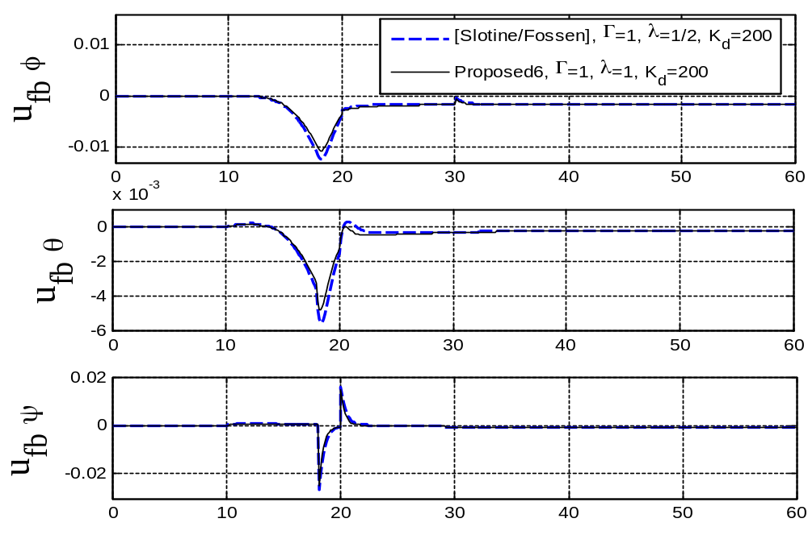
Fig 9 FEEDBACK CONTROLS: Slotine/Fossen Vs. Proposed6 adaptive feedforward (only) with PD feedback control

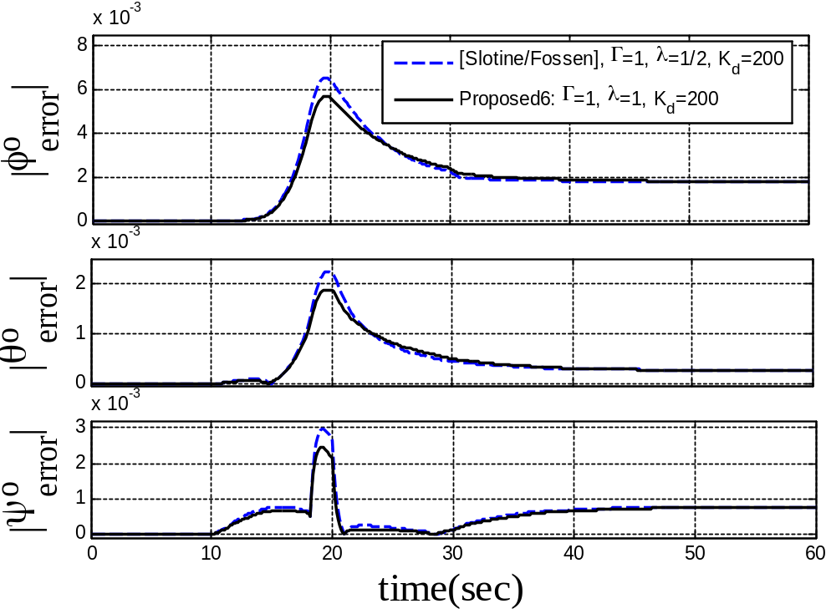
Fig 10 TRACKING ERRORS: Slotine/Fossen Vs. Proposed6 adaptive feedforward (only) with PD feedback control

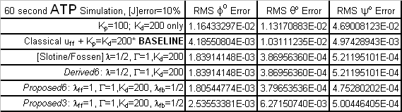Fig 11 NO-NOISE SIMULATION RMS ERROR SUMMARY

Due to the high pointing accuracy achieved, the RMS errors are correspondingly small. Accordingly, a percent-improvement summary is quite revealing. Classical feedforward plus feedback control was established as the baseline, and the feedback gains were normalized for all cases. The published Slotine/Fossen 9-parameter approach provided significant performance increase. Additionally, the derived 6-parameter regression provided equivalent performance (as anticipated). The proposed 6-parameter regression (with decoupled, more aggressive adaptive feedforward) slightly improved performance still further, while the proposed 3-parameter regression adaptive controller provided significantly improved performance with a simple controller.

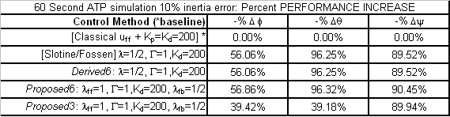
Fig 12 COMPARISON: % performance increase

7. experimental verification
While many modern algorithms seem promising on paper, real world situations often confound some modern algorithms. With this motivation, the proposed new control algorithms presented here have been experimentally verified on a free-floating, three-axis spacecraft simulator.
Spacecraft actual inertia (6) components are unknown. Previous values (prior to payload installation) listed above (Figure 3) are used for classical control design and initializing adaptive controllers.
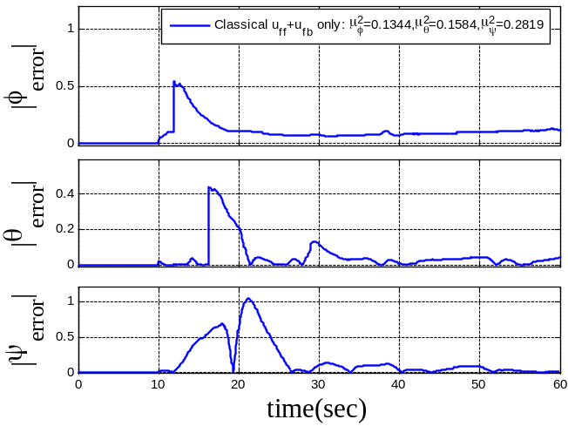
Fig 13 EXPERIMENT for large-angle acquisition maneuver followed by target tracking trajectory: Tracking errors (roll φ, pitch θ, yaw ψ in degrees) for BASELINE Classical feedforward + PD feedback control., Kp=100, K_{d}=200
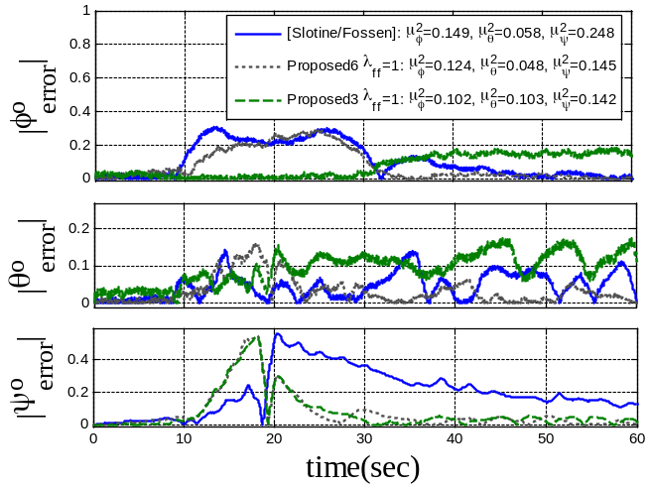
Fig 14 EXPERIMENT for large-angle acquisition maneuver followed by target tracking trajectory: Tracking errors (roll φ, pitch θ, yaw ψ in degrees) comparison: [Slotine/Fossen] where λ=1/2, K_{d}=200; Proposed6 adaptive feedforward & PD feedback control where where λ_{ff}=1, K_{p}=100, and K_{d}=200; Proposed3 adaptive feedforward & PD feedback control where λ_{ff}=1, K_{p}=100, K_{d}=200.

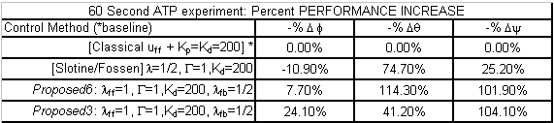
Fig 15 EXPERIMENT RMS ERROR SUMMARY for large-angle acquisition maneuver followed by target tracking trajectory: Tracking errors (roll φ, pitch θ, yaw ψ in degrees) u_{ff}=feedforward control, u_{fb}=feedforward control, K_{p}=proportional feedback gain, K_{d}=derivative feedback gain, [Slotine/Fossen] refers to method in respective literature, Proposed6 refers to proposed 6-parameter adaptive feedforward, Proposed3 refers to proposed 3-parameter adaptive feedforward.

8. conclusions
This paper demonstrates enhanced spacecraft target acquisitions maneuvers and tracking performance utilizing simplified, stable, and convergent adaptive techniques for unknown inertia errors. Initially, a suggested method from the literature is derived and simulated with experimental verification on a free-floating spacecraft simulator. Next, two simplifications to the method in the literature are proposed and compared to the nominal method. The simplifications bestow algorithmic reduction while maintaining performance improvement over typical control methods. Lastly, an alternative adaptive control algorithm is introduced further improving performance and eliminating the reference-adaptation of the feedback signal. 39-96% performance increase is achieved in ideal simulations, and 7-104% improvement was validated experimentally as compared to classical feedforward plus PD feedback control noting the actual error in inertia estimates is unknown, since the experiments were performed on a large free-floating spacecraft simulator with unknown inertia (prior to exhaustive system identification).

Implementation is quite simple. Simply replace the feedforward inertia with an adapted inertia based on the simple adaption rule (equation 17) and the prerequisite reference trajectory (equations 4-5) which is also input to a typical PD controller.

Special thanks to Lieutenant Colonel Michael Pandolfo for his editorial efforts on this paper.

REFERENCES

[] Ahmed, J. “Asymptotic Tracking of Spacecraft Attitude Motion with Inertia Identification”, AIAA Journal of Guidance, Dynamics and Control, Sep-Oct 1998.

[2] Cristi, R., “Adaptive Quaternion Feedback Regulation for Eigenaxis Rotation”, AIAA Journal of Guidance, Dynamics and Control, Nov-Dec 1994.

[3] Sanya, A. “Globally Convergent Adaptive Tracking of Spacecraft Angular Velocity with Inertia Identification”, Proceedings of IEEE Conference of Decision and Control, 2003.

[4] Anderson, E.H., “Adaptive Feedforward Control for Actively Isolated Spacecraft Platforms”, AIAA Structures, Structural Dynamics, and Materials Conference and Exhibit, Kissimmee, Apr 7-10, 1997: AIAA-1997-1200.

[5] Niemeyer, G. and Slotine, J.J.E, “Performance in adaptive manipulator control”, Proceedings of 27th IEEE Conference on Decision and Control, December, 1988.

[6] Slotine, J.J.E. and Benedetto, M.D.Di, “Hamiltonian Adaptive Control of Spacecraft”, IEEE Transactions on Automatic Control, Vol. 35, pp. 848-852, July 1990.

[7] Slotine, J. and Li, W., Applied Nonlinear Control, Prentice-Hall, Upper Saddle River, NJ, 1991, pp. 422-433.

[8] Yoon, H. and Tsiotras, P., “Spacecraft Adaptive Attitude and Power Tracking with Variable Speed Control Moment Gyroscopes”, Journal of Guidance, Control, and Dynamics, Vol. 25, No.6, Nov-Dec 2002.

[9] Fossen, T. “Comments on ‘Hamiltonian Adaptive Control of Spacecraft’ “, IEEE Transactions on Automatic Control, Vol. 38., No. 4, April 1993.

BIOGRAPHIES

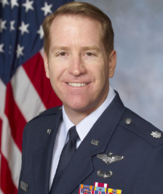
Tim Sands is a graduate student pursuing the Master of Science in Mechanical Engineering at the University of Wisconsin at Madison. His research interests include the dynamics and control of flexible spacecraft; control moment gyroscope attitude control; adaptive control; and physics-based control design.


Dr. Jae Jun Kim is currently Research Assistant Professor, Department of Mechanical and Astronautical Engineering at the Naval Postgraduate School, Monterey, California. His research interests include Acquisition, Pointing, and Tracking (ATP) technology development for Bifocal Relay Mirror Spacecraft; development of control methods for slew maneuvers of a flexible spacecraft; design and upgrade of guidance, navigation, and control system hardware and software of the ground spacecraft testing facilities including: star sensors, inertial measurement unit (IMU), flexible structure simulators, onboard computers, onboard controllers for gimbaled system; and development and integration of optical payload systems to spacecraft test-beds including: telescopes, fast steering mirrors, PSDs, and other optical elements. He has taught courses in Dynamics and Control of Flexible Spacecraft.

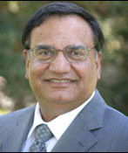
Distinguished Professor Brij N. Agrawal is the Director of the Spacecraft Research and Design Center at the Naval Postgraduate School, Monterey California. He worked for twenty years for Communications Satellite Corporation (COMSAT) and International Telecommunications Satellite Organization (INTELSAT) where he conducted research in spacecraft attitude control, spacecraft structures, spacecraft system designs, and spacecraft testing. He participated in the development of INTELSAT IV, IV-A, V, VI, COMSTAR and MARISAT satellites. He wrote the first text book on spacecraft design “Design of Geosynchronous Spacecraft” and was awarded a patent on attitude pointing error correction system for geosynchronous spacecraft.

978-1-4244-2622-5/09/$25.00 ©2009 IEEE
IEEEAC paper #1638, Version 2.0, Updated November 7, 2026

